**8 Aug 2014** **The Weekly Bulletin of Rotary Club of Kathmandu Mid-Town** **bc-06/8.014**

|  |
| --- |
|  |

District: 3292 Web:www.rotarymidtown.org.np Club Id: 26776

**AUGUST IS MEMBERSHIP & EXTENSION MONH**

**Celebrating**

**25 Years in Rotary**





Friday, 1 August :



Guest Speaker Sheri Meyerhoffer, ID Head of Mission, International EA, Nepal, gave a short

talk on Constitution Making in Nepal - Opportunities and Challenges with an interesting

power-point presentation.

As a background she stated that peace in Nepal was reached through compromise and

consensus based on an agreement that Nepal would be a federal republic, secular and

inclusive. Talking about the opportunities Nepal has to create the best federal republic the

world has seen to date, she provided many examples. A new federal constitution also provides

Nepal with an opportunity to recognize and benefit from Nepal’s rich diversity of peoples and

cultures. A constitution built upon consensus and inclusion will receive buy-in or ownership

from all Nepali groups and communities. This will provide the stability that Nepal needs to prosper by attracting both foreign and national investment.

She also talked about innumerable challenges we face to reach agreement on a form of government that provide good governance, balance of power and representation, an electoral system that ensures inclusive representation, number, name and boundary of Nepal’s federal units, a form of competent and independent judicial system.

On issue of state restructuring they need to consider seriously economic and geographic factors, historic boundaries, ensuring political balance and considering public opinion as well. She also provided some examples of identity based names, and a few federal countries each with number of provinces.

She concluded her presentation with a quote of *Anton Checkhov* on political will - *“You already know enough. So do I. It is not knowledge we lack. What is missing is the courage to understand what we know and to draw conclusions.”*

She also addressed to some questions raised from the floor after her presentation and appreciated the interests and comments.

# Weekly Meetings and Prorams :

|  |  |  |
| --- | --- | --- |
| Date | Program/Speaker | Program/Topics of Presentation |
| 8 August | Shambhu Simkhada | ?? |
| 15 August | ?? |  |
| 22 August | ?? |  |

**Friday, 8 August :**

??

Shambhu Simkhada is our guest speaker.

**Naag Panchami**  : 1 August



Naag Panchami, which is also called the day of snakes, was observed across

the country by worshipping and honouring the snakes with red vermilion

powder, milk, ghee, sweets and flowers on 1 Aug. On the occasion, image

of snakes with mantras is pasted above the entrance of the house. It is

believed that doing so keeps poisonous snakes away from the house.

As per mythology it is said that once when a farmer was tilling a land he

accidentally killed a snake family. One member of the snake family which

had gone a stroll during the accident returned home and found that entire

family was killed. In order to seek revenge the snake killed all family members of the family except his daughter who was at her in-laws house. Guided by intention to bite the snake is said to have gone to her house to bite. Since the day was Naga Panchami the snake saw that the daughter was praying to Sheshanaga (Snake Lord) with utmost devotion. The snake which was fuming with anger is said to have fallen into the milk kept on the window sill and immediately became calm. Impressed by her devotion the snake which spoke in human voice told her that he had killed all her family members and asked her what boon she wanted. The daughter in turn asked the snake to bring all the members back to life. The snake granted her wish.

**World Breastfeeding Week, 1-7 August.**

‘Breastfeeding: a Winning Goal – for Life’

World Breastfeeding Week is celebrated every year from 1 to 7 August in more than 170 countries to encourage breastfeeding and improve the health of babies around the world. It commemorates the Innocenti Declaration signed in August 1990 by government policymakers, WHO, UNICEF and other organizations to protect, promote and support breastfeeding. Breastfeeding is the primary source of nutrition for babies Breast milk is readily available and affordable. WHO recommends exclusive breastfeeding starting within one hour after birth until a baby is six months old. Nutritious complementary foods should then be added while continuing to breastfeed for up to two years or beyond. Breastfeeding improve baby’s health. People who were breastfed as babies are less likely to be overweight, less prone to diabetes and they perform better in intelligence tests. Benefits of breastfeeding also appear to stay with mothers for years to come, lowering risks of cardiovascular disease and cancer.

On the occasion of world breastfeeding week:



TIME stirred up its own breastfeeding controversy when the

magazine featured a photo of 26-year-old Jamie Grumet breast-

feeding her 3-year-old son on a [May 2012 cover](http://content.time.com/time/covers/0,16641,20120521,00.html).

Critics questioned both the decision to breastfeed a child that old

and the choice to put the photo on TIME‘s cover.

><><><><><><><><

A woman was kicked off the Plane for breastfeeding!

A legal dispute over public breastfeeding began in 2006 when

[Emily Gillette](http://content.time.com/time/specials/packages/article/0,28804,2053230_2053229_2053225,00.html) said that a Delta flight attendant told her to get

off the plane when she refused to cover up while nursing her

22-month-old daughter. She was sitting discreetly by the

window with her husband in the aisle seat when a flight

attendant gave her a blanket. After Gillette declined the blanket, she was escorted off the plane. Gillette filed a civil suit against Delta in the U.S. District Court in the fall of 2009. Gillette settled with the airlines for an undisclosed amount in March 2012.

*Source: Internet news*

On Lighter Side :



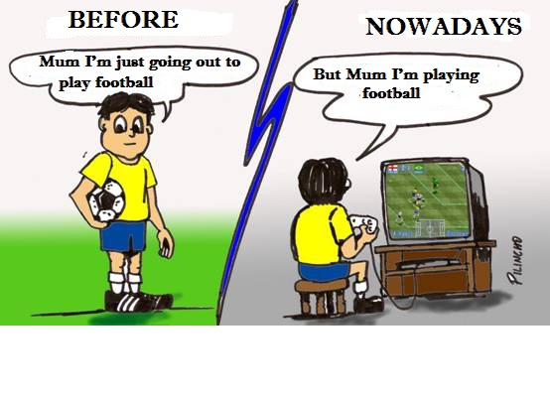

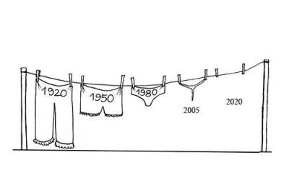

*Courtesy: Rtn Isabella CB Khadka*

Great quotes :

**Kind hearts are the gardens, Kind thoughts are the roots,**

**Kind words are the flowers, Kind deeds are the fruits,**

**Take care of your garden And keep out the weeds,**

**Fill it with sunshine Kind words and Kind deeds”**



Be positive. Maybe you have heard the phrase, “Think good and it will be good.” Think the best of

every body. Look on the bright side. If you see things are not right, you don’t have to complain, and you

also don’t have to pretend it’s OK. Instead, say, “OK, this is not right, so how do we make it better?”.

**RI President GARY C.K. HUANG**

Please send information on club activities, progress reviews on service projects, relevant photos etc to:

BC Editor: RR Shrestha email: rryesrr@gmail.com

## 8 August 2014 The Weekly Bulletin of Rotary Club of Kathmandu Mid-Town bc-06/8.014